Football Season Organizer

Author(s): Joshua Ruiz

CST-451 Capstone Project Requirements Document

Grand Canyon University

Instructor: Professor Mark Reha

Revision: 8/27/2023

Date: 8/27/2023

**ABSTRACT**

Summarize the entire project in 2-3 paragraphs, about 15-20 lines. The abstract should be enough for one to get an idea of what this project is about, what was the task, and what you accomplished. Briefly provide the broader context. Write this section only after the entire project is complete.

|  |
| --- |
| History and Signoff Sheet |

**Change Record**

|  |  |  |
| --- | --- | --- |
| **Date** | **Author** | **Revision Notes** |
| 8/27/2023 | Joshua Ruiz | Initial draft for review/discussion |
|  |  |  |
|  |  |  |

|  |
| --- |
| **Overall Instructor Feedback/Comments** |

|  |
| --- |
| **Overall Instructor Feedback/Comments** |

**Integrated Instructor Feedback into Project Documentation**

Yes  No

**TABLE OF CONTENTS**

Functional Requirements 4

Non-Functional Requirements 5

Technical Requirements 6

Logical System Design 7

User Interface Design 8

Reports Design 9

Functional Requirements

**Use Cases**

Describe the sequence of functional actions a project performs with either textual Use Cases, UML Use Case diagrams, or if using Scrum, provide a link to the User Stories (see template included in course materials).

NOTE: Once the functional requirements have been completed, there may be situations where Use Cases or User Stories may need to be taken out of scope, possibly due to technical challenges or timeline challenges. Any Use Cases or User Stories that are taken out of scope once the project development has started must be approved by the mentor and instructor with justification as to why the functionality is being removed from the project. The following must be updated if any Use Cases or User Stories are taken out of scope:

|  |  |  |
| --- | --- | --- |
| **Use Case or User Story** | **Approval Date** | **Justification** |
| The application will utilize an import process that allows for data to be moved into Amazon AWS for data storage and hosting. These imports will either be mass uploads or through individual team schedule updates for high school football schedules. NFL APIs exist but will not be able to be used due to licensing costs/requirements |  |  |
| The application will have a form that will allow the user to input game information manually for high school teams. |  |  |
| The application will allow a user to create/edit/delete their account from the application |  |  |
| The application will allow each user login to add favorite teams from NCAA, NFL, and manually input high school teams into the organizer as well as remove favorites from their profiles |  |  |
| The application will display the game schedules for all favorited teams in both calendar and list formats, will display teams for only a selected team, or for a selected league |  |  |
| The application will be a web based application and the UI will utilize React.js to create a UI that will give the user a easy to use streamlined look. |  |  |
| The application will display multiple pages like outlook calendar functionality where the games can be viewed in month, week, & day views. It will also allow for everything to be listed in a table format with excel export functionality. |  |  |
| The application will send out email reminders to the user for upcoming games along with calendar reminders while utilizing the application. |  |  |

***NOTE: If necessary, you may add subsections to those listed in order to match the requirements in the assignment description. Do not remove any top-level sections (those that are listed in the Table of Contents). As required by your project, you may add additional top-level sections (please update the Table of Contents).***

Non-Functional Requirements

**Use Cases**

Describe the sequence of non-functional actions a project performs with either textual Use Cases, UML Use Case diagrams, or if using Scrum, provide a link to the User Stories (see template included in course materials).

NOTE: Once the non-functional requirements have been completed, there may be situations where Use Cases or User Stories may need to be taken out of scope, possibly due to technical challenges or timeline challenges. Any Use Cases or User Stories that are taken out of scope once the project development has started must be approved by the mentor and instructor with justification as to why the functionality is being removed from the project. The following must be updated if any Use Cases or User Stories are taken out of scope:

|  |  |  |
| --- | --- | --- |
| **Use Case or User Story** | **Approval Date** | **Justification** |
| The application will encrypt passwords for storage in the users table: Password requirements will be min 10 characters with lowercase letters, uppercase letters, numbers, and Special characters. |  |  |
| The application will utilize Amazon AWS in order to scale based on data usage. |  |  |
| The application will require the use of Chrome, Edge, or Firefox to operate correctly. |  |  |
| The application will have downtime once a year while the new rosters and schedules are being updated. The downtime will be a few hours as the data is updated. Users only need to access the application a few times a week. Downtime should be minimal. |  |  |
| Maintainability and Manageability will have minimal impact as the application will not have a wide user base nor will it be a larger enterprise level application. This will change as functionality is added to the application or the user base starts to increase. |  |  |
| The application will have high usability as the UI will have easy navigation buttons along with different data views configurable for what the user likes best. |  |  |
| Each page must load within 10 seconds |  |  |

Technical Requirements

**Use Cases**

Describe the tools and technologies used in the project.

NOTE: Once the technical requirements have been completed, there may be situations where technologies or tools may need to be taken out of scope or changed, possibly due to technical challenges or timeline challenges. Any technologies or tools that are taken out of scope or changed once the project development has started must be approved by the mentor and instructor with justification as to why the functionality is being removed from the project. The following must be updated if any technologies or tools are taken out of scope or changed:

|  |  |  |
| --- | --- | --- |
| **Technology or Tool** | **Approval Date** | **Justification** |
| Programming Language: Java |  |  |
| Framework: Spring |  |  |
| IDE: Spring Boot |  |  |
| REST: Spring Data REST |  |  |
| UI: React.JS |  |  |
| Git: Github w/ SourceTree to help version the application |  |  |
| Data Storage/Access/Application hosting: Amazon AWS (Free Tier) |  |  |
| Postman: Test application API functionality |  |  |
| Chrome, Edge, Mozilla: Application function testing and UAT |  |  |
| Draw.io: UML, Mapping, Storyboarding, Flowcharting, etc. |  |  |
| CodeWhisperer: simplify integration of application into AWS |  |  |

Logical System Design

Provide a diagram of the logical architecture of the system.

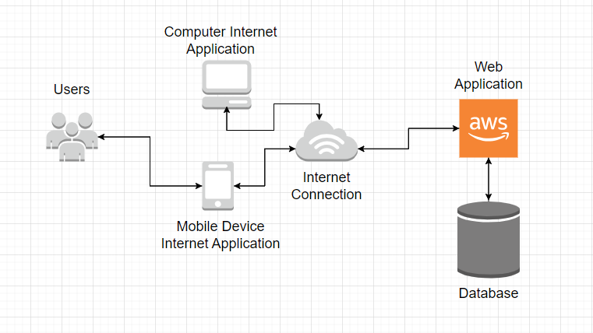

User Interface Design

Provide a sitemap and user interface design diagram for each user interface screen in the application, if not applicable, define the components of the project as described in the handbook.

Site Map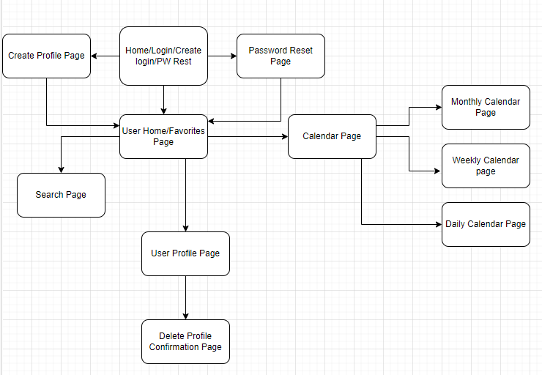

Wireframe

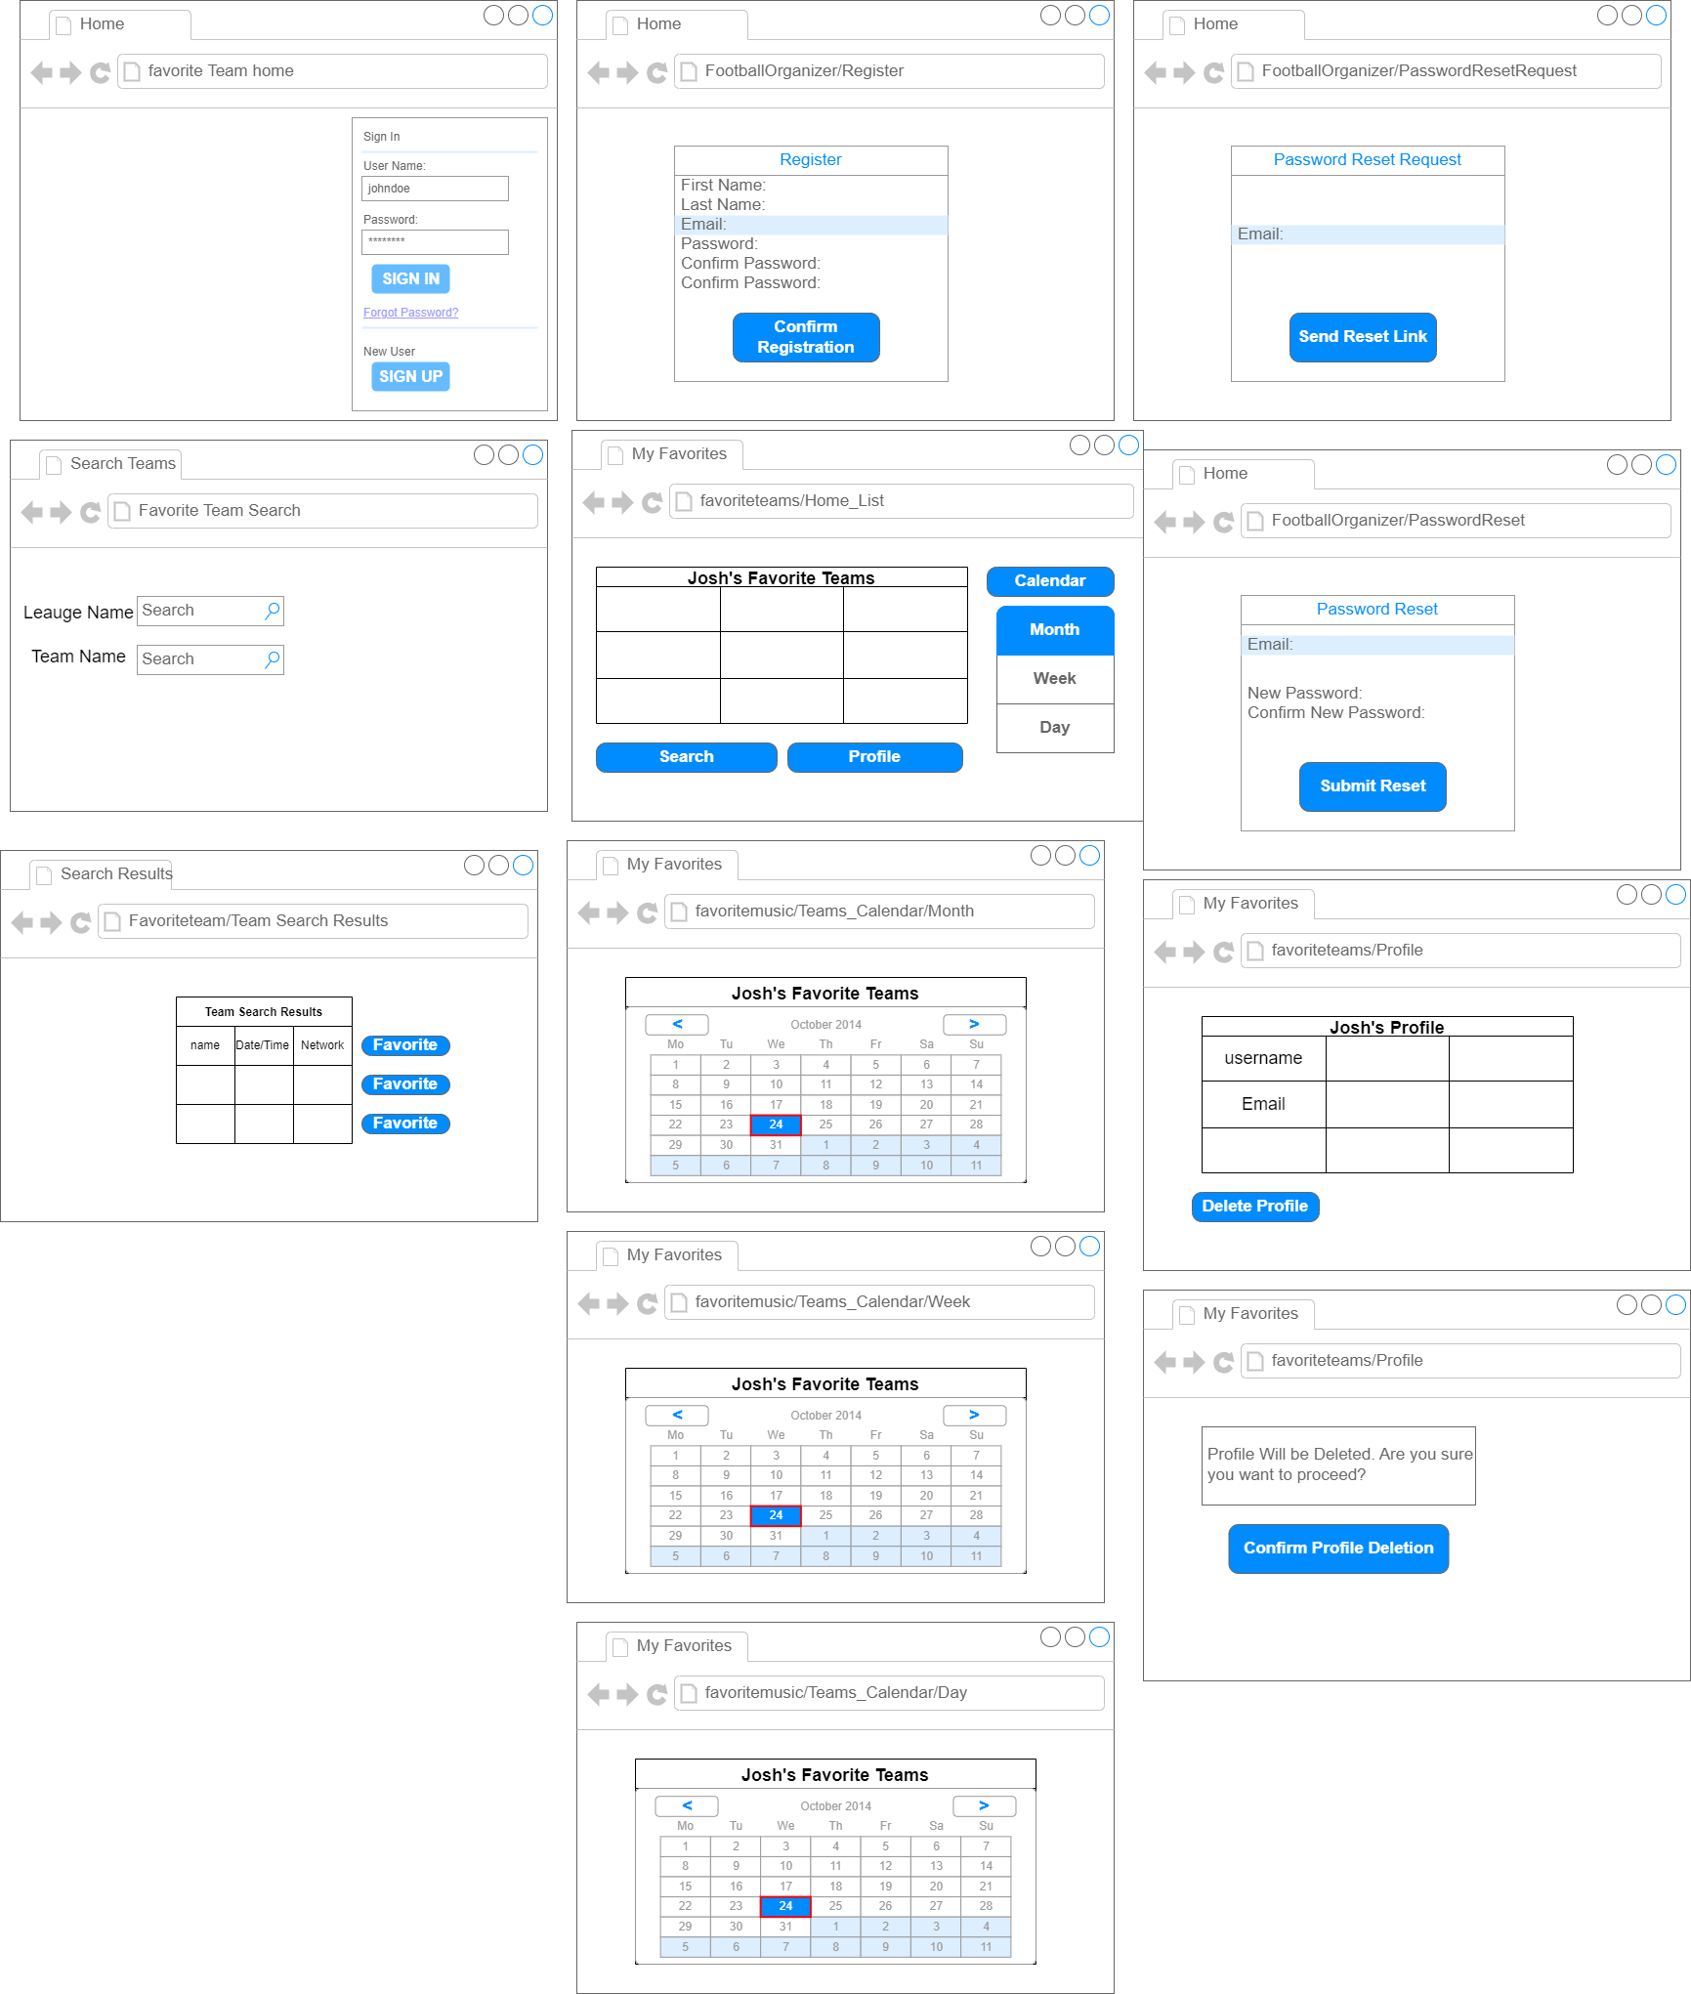

Reports Design

Provide a listing of the reports that the system will provide, if applicable. If not, state that the system does not produce any reports and provide additional documentation as described in the handbook.

1. Error Logs
2. The Favorite Teams game schedules will be able to be exported to Excel to allow for print functionality.
3. Admins will be able to pull AWS included BI reports through the Free tier access level.